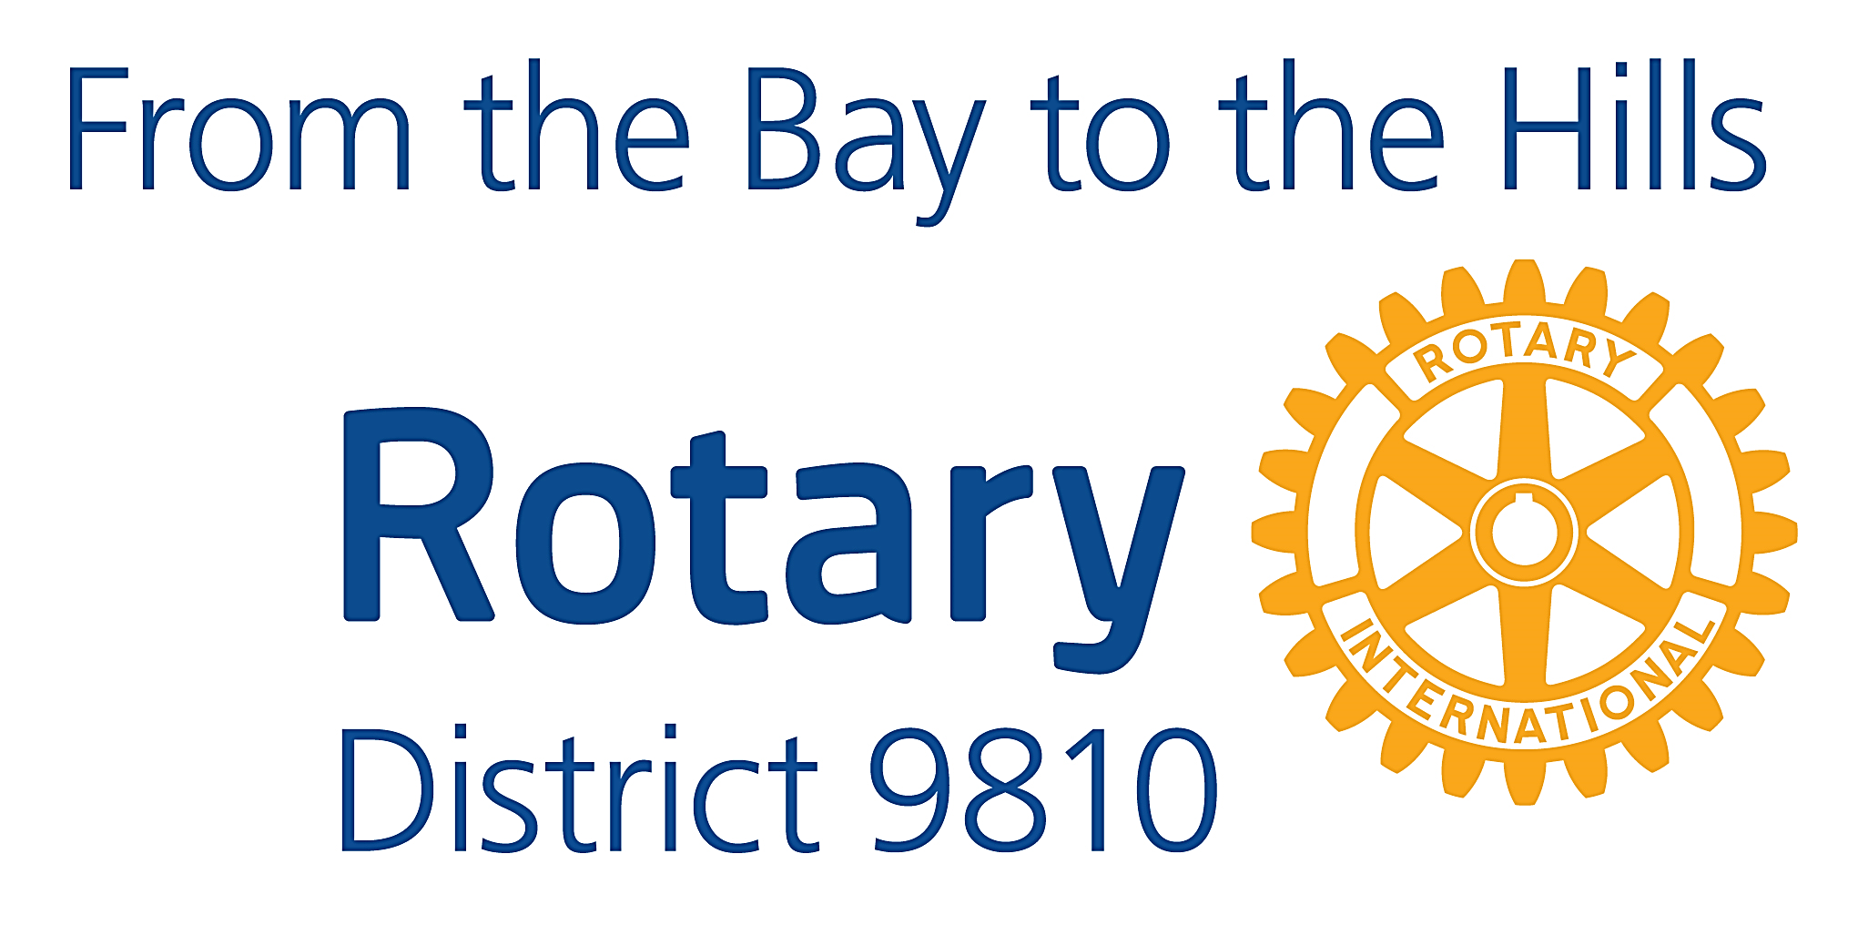
Russell Gurney
Governor, 2018-19

T 0407 212 406
E rjgurney9810@gmail.com

14 December 2018

To: Club Presidents and Secretaries,
Rotary International District 9810 Inc.

NOMINATIONS ARE CALLED FOR THE FOLLOWING POSITIONS:
- Members of the District Governor Nominating Committee 2018-19
(to select the District Governor for 2021-22)

AND
2. District Governor 2021-22

I would be pleased if you could advise all Club members that the nominations are now open and will close as follows:
• Nominations for the District Nominating Committee 2018-19
- Friday, 1 March 2019 at 5pm;
• Nominations for District Governor 2021-22
    - Friday 22 February 2019 at 5pm.

Completed and signed nomination or application forms should be submitted to PDG Malcolm Chiverton, Secretary District 9810 Nominating Committee, by email at malcolm.chiverton@bigpond.com or by registered post to 5 Lofty Avenue, Camberwell 3124.

MEMBERS OF THE DISTRICT NOMINATING COMMITTEE 2018-19
The District Nominating Committee consists of ten Rotarians, five of whom are representatives from Clubs and must be either a past or current Club President. The other committee members are the District Governor (Chair), District Governor Elect, District Governor Nominee, Immediate Past District Governor (Secretary), and one other Past District Governor.
Full details governing the operation of the Nominating Committee are contained in the By-laws of Rotary International District 9810 Inc. (By-law 7).
Copies are available for download on the District website www.9810rotary.org.au
It should be noted that the club of which any candidate for District Governor [2021-22] is a member, cannot have a member on the Nominating Committee.
In addition, District By-Law 7.1.2.3 states that a Past President cannot serve on consecutive Nominating Committees
Nominations for the committee must be submitted on the attached form and include a short (200-word, maximum) summary of the Nominee’s Rotary experience. This will be included in any ballot correspondence if more than five Rotarians are nominated.
Members of the Committee are to be available to convene for the District Governor 2021-22 interviews to be held on Sunday, 14 April 2019 at the Monash Enterprise Centre, 5a Hartnett Close, Mulgrave 3170.
Completed forms must reach PDG Malcolm Chiverton by 5:00pm, Friday 1 March 2019.

DISTRICT GOVERNOR 2021-22
I urge you to encourage suitable members to consider this rewarding and vital role in their future Rotary service. Please consult with senior members of your club to discuss the role with those you feel can provide this great contribution to Rotary and our District.
Prospective nominees should also take the opportunity to speak with members of the College of Governors about the requirements and benefits of the role.
These actions are recommended in order to gain a balanced and realistic appreciation of the role as well as the interview process and requirements.
As a minimum, an applicant for the role of District Governor must:
- Be in good standing in their Club (i.e. financial)
- Have served as president of a Club for a full term or as specified in the Rotary Manual of Procedure, and
- At the time of taking office (1 July 2021), must have completed seven years of membership with one or more Rotary Clubs.
Candidates should refer to the detailed qualification requirements and the responsibilities and roles of the District Governor as contained in sections 16.070 to 16.090 on pages 70/71 of the 2016 edition of The Rotary Manual of Procedure.
Application is via the District Governor Nominee Data Form included with the email carrier. Copies are also available for download on the District website at www.9810rotary.org.au
Candidates are also required to include a brief Rotary resume and a written statement of their vision for the 2021-22 Rotary year with their application. They should be prepared to make a 10-minute oral presentation, without electronic visual aids, on this vision during the interview.
Confidential interviews will be held on Sunday, 14 April 2019 at the Monash Enterprise Centre, 5a Hartnett Close, Mulgrave 3170.
Applicants and their partners, if applicable, are required to be available on that date. Specific timing will be advised before then to aid planning.
Please encourage all members entitled to participate in this most important activity to give serious consideration to putting themselves forward.
Completed form, Rotary resume, and vision outline must reach PDG Malcolm Chiverton by 5:00pm, Friday 22 February 2019.

All enquiries about any of these matters should be directed to PDG Malcolm Chiverton, Secretary District 9810 Nominating Committee - District Governor 2021-22.

In Rotary service,
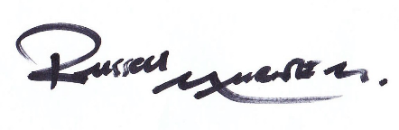
Russell Gurney
Governor 2018-19

